Assignment

Abhishek Jaiswal

**Architecture:**

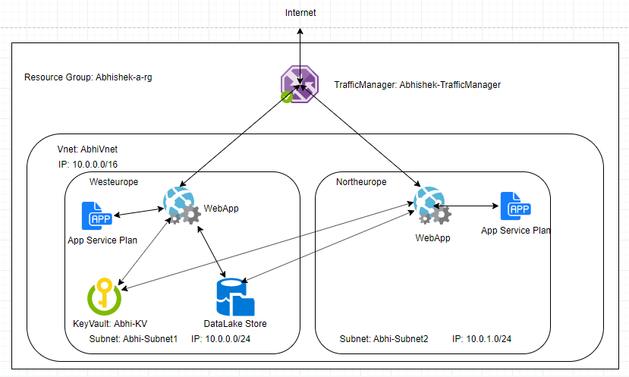

As per architecture the application flow will be as the Traffic manager will be getting request from internet. At backend two webapp has been configured at different location for availability purpose. The traffic manager will send the request to either of webapp based on performance. The webapp will get the authentication key from Keyvault in order to get access to datalake store.The webapps are being created based in app service plan. All the services are created in a Vnet. There are 2 subnets created under the Vnet where resources are getting created. Only the traffic manager will be configured to access webapp from outside of Vnet. A secondary datalake and keyvault can be created in sebnet2 for availability purpose.

**Resource Creation**

All the resources will be created with ARM template. For each resources, ARM template file and parameter file has been created. The same ARM template can be used to deploy resource but parameter file need to be changed.

The ARM template can be deployed in 2 ways, we can use template deployment feature in Azure portal or we can use powershell script to deploy the resources.

There are 2 powershell script has been included.

DeployResourceGroup.ps1 (It can be used to deploy the resource group)

DeployResource.ps1 (This script can be used to deploy other resources.)

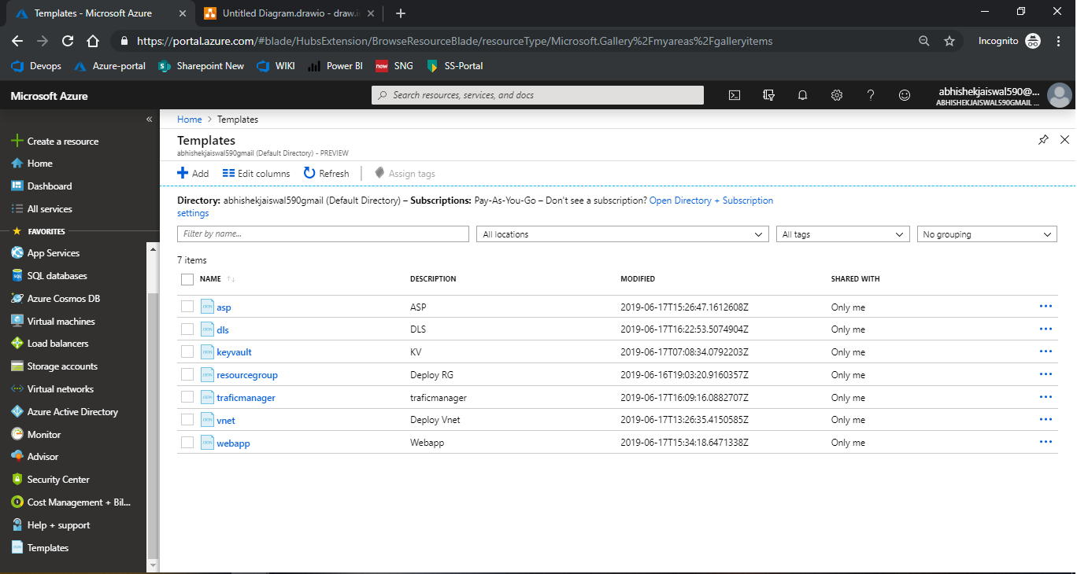

**Deployment Sequence:**

All the resources need to be deployed in below order to make configuration feasible.

1. Resource Group
2. Vnet
3. KeyVault
4. App Service Plan
5. WebApp
6. Traffic Manager
7. Datalake Store

Note: Deletion lock has been enabled on Vnet and datalake store so that accidental deletion of the resource can be prevented.

The provided templates are tested and POC completed for same.

